Task 1.2
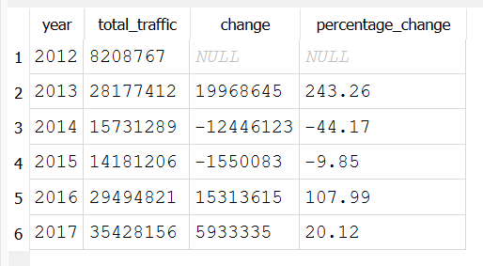
Observation 1 – Overall trend
Overall, traffic volume showed a generally increasing trend between 2012 and 2017. The traffic volume was highest in 2017 and lowest in 2015. This indicates that the level of traffic changed over the six-year period rather than remaining constant.
Observation 2 – Significant increase/decrease
The largest year-to-year increase occurred between 2015 and 2016 with traffic volume increasing by 15313615,equivalent to 108%. In contrast, the largest decrease occurred between 2013 and 2014, where traffic volume fell by 1244612 or 44%. This suggests that traffic patterns experienced some significant fluctuations during the period.
Task 1.3
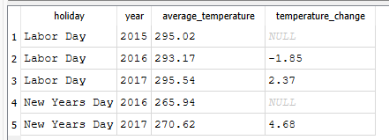
The temperature change is not sufficient to establish a direct relationship with traffic volume. Traffic volume increases or decreases in the same period as the temperature change.
Task 2.1 Traffic volume statistics
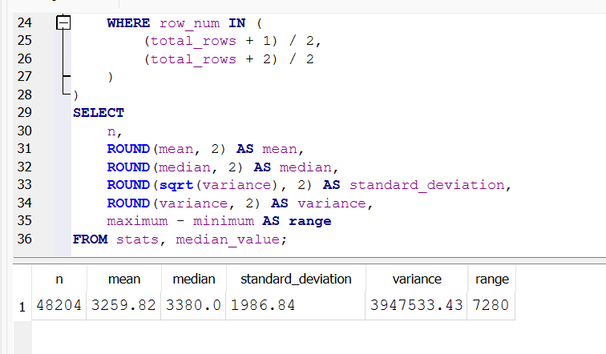
The descriptive statistics show that the average traffic volume was 3,259.82, while the median was 3,380. Since the median is slightly higher than the mean, the data appears to have some lower traffic-volume observations that reduce the average. The standard deviation of 1,986.84 indicates considerable variability in traffic volume, meaning that traffic levels can differ substantially between observations. The variance of 3,947,533.43 confirms that there is a large amount of variation in the dataset. Finally, the range of 7,280 shows a substantial difference between the minimum and maximum traffic volumes. Overall, the statistics indicate that traffic volume is not consistent and varies considerably across the observations.
Task 2.2
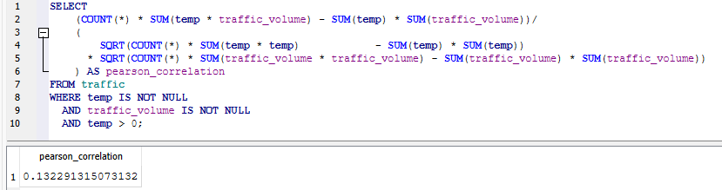
Direction — positive. The sign is positive, so temperature and traffic volume tend to move in the same direction: as temperature rises, traffic volume tends to rise slightly too (and vice versa).
Strength — The strength of the relationship is very weak, bordering on negligible. In practical terms, temperature provides almost no useful information about traffic volume.
The weak positive correlation is most likely a byproduct of shared timing rather than a genuine causal mechanism. Both temperature and traffic volume follow daily and seasonal cycles — higher temperatures and heavier traffic both occur during daytime and summer (commuting hours, longer daylight, better driving conditions). A confounding variable, time of day and season, therefore drives both upward together, producing a faint positive correlation even though temperature does not place vehicles on the road.
Two caveats apply: correlation is symmetric, so the coefficient alone cannot establish the direction of any influence (and traffic clearly does not raise air temperature); and in a large dataset, a small non-zero value can arise partly by chance. The reasonable conclusion is that this near-zero coefficient indicates no direct causal relationship between temperature and traffic volume — only a shared dependence on time.

Task 3.2 Conditional probability
- P(Clear Weather | Congestion)
- P(High Temperature | Congestion), where high temperature > 292K
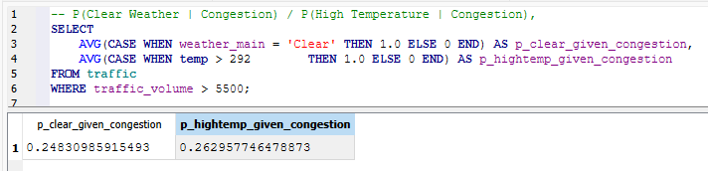
- Determine whether weather conditions and congestion can be considered independent using P(A ∩ B) = P(A) × P(B)
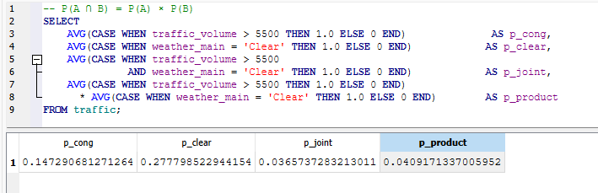
The two values (0.0366 vs 0.0409) are close enough that the equation P(A ∩ B) = P(A) × P(B) approximately holds, which is the condition for independence. The small gap is negligible and within normal sampling variation, so there's no meaningful association between clear weather and congestion.
- Calculate the odds ratio of congestion in clear versus cloudy weather.
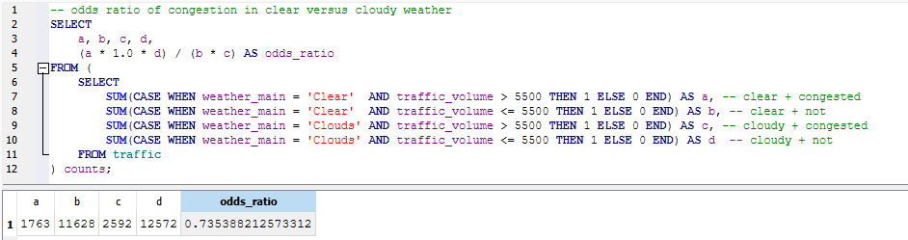
The probability analysis indicates that weather conditions and congestion are only weakly related and can be considered approximately independent. The observed probability of clear weather and congestion occurring together (0.0366) was very close to the value expected under independence (0.0409), showing that clear weather has little effect on the likelihood of congestion.
The odds ratio of 0.735 supports this finding, indicating that congestion is slightly less likely in clear weather than in cloudy weather, though the effect is weak. Consistent with the earlier weak temperature–traffic correlation (r ≈ 0.13), these results suggest that weather is not a significant driver of congestion, which is more likely explained by factors such as time of day and commuting patterns. Furthermore, this weak association should not be interpreted as causal, as both weather and traffic volume follow similar daily and seasonal cycles.

